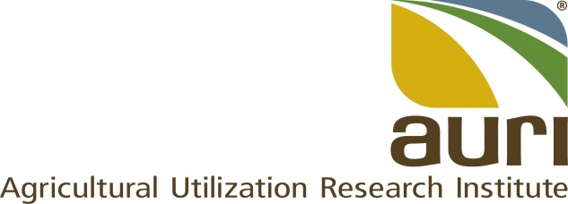

POSITION DESCRIPTION

Title: | Bio Industrial Technical Associate
FLSA Status: | Exempt
Reports to: | Senior Scientist of Coproducts
Location: | Waseca
Avg # travel days per month: | Up to 5
Purpose: | This position supports AURI mission to develop bio industrial added value opportunities for producers by ensuring that the Waseca bio industrial laboratory and its equipment are properly maintained and operated. This position will be able to independently carry out work to implement technical tasks and achieve goals as assigned.

The following are examples only and are not intended to be “all inclusive” or restrictive. Other duties may be assigned as necessary.

Responsibility | Job Task | Percent of Time
Support the bio-industrial lab operations in Waseca. | - Under the direction of the laboratory Senior Scientist, maintain, repair, and operate the Waseca laboratory equipment.  - Ensure that the lab and the equipment are always ready to operate while maintaining and enforcing approved safety procedures.  - Ensure that feedstock samples from clients and partners are properly received, stored, and distributed.  - Ensure that processed samples are properly handled, classified, and distributed inside and outside AURI.  - Carry out supervised or unsupervised test runs following direction of senior staff while ensuring compliance with approved standard operating procedures (SOP’s).  - Support and execute field trials at producers’ location.  - Support tolling operations and third parties using Waseca facilities.  - Responsible for the timely coordination and execution of larger maintenance and repair tasks using external resources and contractors.  - Identify gaps between available equipment and requested operations and recommend actions.  - Ensure that the laboratory is always properly stocked with needed supplies, consumables, and spares.  - Ensure that the laboratory and the equipment are kept clean and operable after uses.  - Ensures that equipment and laboratories are always functional and ready for operation.  - Ensures that appropriate certifications and permits, as applicable, are current.  - Ensures that compliance with certifications and permits is kept at all times. | 80%
Support general operations of the Waseca lab. | - Support senior staff in reporting and data analysis as required.  - Provide demos to clients and stakeholders  - Support AURI’s outreach activities as needed | 10%
Other responsibilities. | - Other duties as assigned. | 10%

Experience, Education and Training
Minimum Qualifications
- High School diploma with trade training and two years’ experience in industrial equipment operation and maintenance.
- Experience in operating and maintaining basic ag-related process equipment such as dryers, filter presses, mixers, various types of pumps, hammer mills, grinders, separators, presses, expellers, etc.
- Understanding of fluids and solid behavior.
- Understanding of electrical circuits and services.
- Ability to translate process functional requirements into operational procedures and formalize them into standard operating procedures (SOP) for specific type of equipment.
- Ability to run equipment unsupervised when applicable while maintaining safety.
- Ability to define and carry out maintenance program for equipment and other laboratories assets including small repairs.
- Ability to collect and organize data in electronic format and present it in tabular and graphical form.
- Computer and Microsoft office software proficiency.
- Valid driver’s license.

Preferred Qualifications
- Formal training or certification in one or more of the following trades: machining, welding, pipefitting, carpentry, mechanics, electrical, production agriculture and two years of related experience.
- Associate degree or the equivalent in a field of science, agriculture, engineering, or industrial operation and two years of related experience.
- Experience or ability to learn fundamental field-testing techniques such as liquid, gas, and mixed samples collection and titration (TKN, VFA, NH₃/NH₄+), pH measurement, dissolved O₂, and others.
- Detailed understanding of high and low-voltage electrical systems, an ability to carry out basic programming and operations of PLCs and VFD, and the ability to read electrical line diagrams.
- Theoretical knowledge of the principles of biomass handling operations such as size reduction, drying, dewatering, densification, and ancillary operations.
- Ability to deduct from pilot scale test runs fundamental functionality, specifications, and size requirements of scaled-up systems for one or multiple relevant unit operations.

