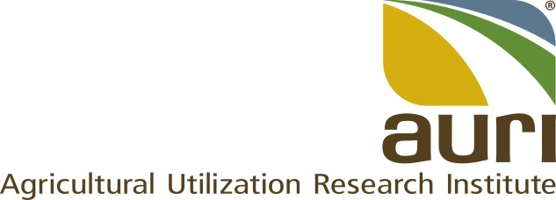

POSITION DESCRIPTION

Title: | Meat Innovation Specialist
Employee: | TBD
FLSA Status: | Exempt
Reports to: | Senior Director of Science and Innovation
Location: | Marshall, MN
Avg # travel days per month | 4
Purpose: | Integrate novel and existing meat innovations to AURI stakeholders and clients by providing meat science leadership through product development and scale up assistance, education and training coordination, oversight and management of the meat laboratory, explore new innovations and develop robust professional networks. This position facilitates the successful execution and development of new projects and initiatives that further the research priorities of the organization. Provide direct assistance or connections to the meat sector or refer to service providers and partners.

The following are examples only and are not intended to be “all inclusive” or restrictive. Other duties may be assigned as necessary.

Responsibility | Job Task | Percent of Time
Product development and scale up assistance | - Address business development needs related to the meat sector.  - Conduct assessments to ascertain preliminary markets, technical, and economic feasibility.  - Assist clients in navigating regulations and connecting with appropriate state and federal resources, including HACCP documentation training and resources.  - Provide services to promote and develop local meat products.  - Deliver technical assistance and product development, scale up, sensory testing and labeling services for entrepreneurs.  - Develop product and recipe formulations to increase stakeholder entrance into niche markets.  - Serve as the principal investigator of client projects and initiatives related to meat products.  - Identify and conduct applied research, including project design, data collection, data analysis and reporting as well as provide formulation, costing, labeling, processing and other appropriate services to clients  - Identify, plan, and direct areas of opportunity for the development of value-added meat products that have the most likelihood for strong economic impact, e.g., local meat, niche and clean label meat products, industry sustainability goals, meat quality attributes and meat industry capacity and resiliency. | 35%
Education and training | - Lead and direct training and educational events for industry and academia.  - Provide HACCP and sanitation training to clients using the Meat Lab in conjunction with project-related activities.  - Conduct short courses, demonstrations and tours of AURI’s Meat Lab, and develop seminars for industry events and trade shows.  - Develop ideas for AURI Connects programming including Food Industry Thoughts Leaders and Webinar Wednesdays.  - Seek out collaborators when applicable including universities and industry groups when developing content and events.  - Participate in consumer and youth outreach events pertaining to work scope.  - Coordinate educational program and outreach collaborations with universities, processor groups, or other stakeholders to expand general meat science knowledge  - Conduct demos – product and fabrication (strengthens producer knowledge)  - Collaborate with educational providers on programs/outreach to expand general meat science knowledge. | 30%
Manage the meat laboratory | - Oversee the AURI meat laboratory including inspection licensing, equipment maintenance, and scheduling and coproducts food lab.  - Procure novel equipment for stakeholder usage: product development processes, scale ups, scale downs, or product launches  - Build relationships with new technology providers, start-ups and equipment manufacturers to create a demonstration program.  - Expose meat industry professionals to new technologies and simultaneously offer valuable feedback and potential co-design concepts to developers.  - Advance opportunities for Entrepreneur in Residence candidates.  - Manage organization’s meat lab operations and leverage related meat facilities, e.g., the product evaluation and sensory lab and coproducts food grade lab.  - Consider opportunities for Early Production Services Program candidates. | 10%
Build robust professional network | - Network at stakeholder conferences / conventions to provide contacts and resources for any value-added product needs  - Build robust meat network and connect relevant groups/individuals  - Serve on AURI’s food team and business development team. | 10%
Explore new innovations. | - Develop new ideas and explore patentable products and processes. | 10%
Other duties | Perform other duties as assigned. | 5%

Experience, Education and Training
Required
- Master of Science in Animal Science or a closely related field and 3 years of related experience.
- Broad knowledge of animal agriculture, including swine and/or small ruminant animal production.
- Knowledge of HACCP and sanitation principles, including related microbiology and chemistry.
- Strong oral and written communication skills as well as strong interpersonal skills.
- Computer and database proficiency
- Ability to handle multiple demands and set priorities.
- Valid Driver's license and personal transportation.
- Ability to travel and work after hours/weekends as needed.

Preferred
Ph.D. in Animal Science or a closely related field

Must be able to lift at least 50 pounds safely to conduct livestock demonstrations and training.

